CHAPTER THREE
INTERLEAVING

3.1 Overview

This chapter gives an introduction to the interleaving process which is useful when a jammer tries to interfere with the transmitted data. Interleavers, together with error correcting codes, are often chosen to combat a jamming signal or a multipath channel environment.

3.2 Impact of Interleaving

An interleaver is a device that permutes the order of a sequence of symbols. A
deinterleaver is the corresponding device that restores the original order of the sequence. A major application is the interleaving of modulated symbols transmitted over a communication channel.
After deinterleaving at the receiver, a burst of channel-symbol errors or corrupted symbols is dispersed over a number of code words or constraint lengths, thereby facilitating the removal of the errors by the decoding.
Ideally, the interleaving and deinterleaving ensures that the decoder encounters statistically independent symbol decisions or metrics, as it would if the channel was memoryless. Interleaving of channel symbols is useful when error bursts are caused by fast fading, jamming, or even decision directed equalization.
A channel that has memory is one that exhibits mutually dependent signal transmission impairments. A channel that exhibits multipath fading, where signals arrive at the receiver over two or more paths of different lengths, is an example of a channel with memory. The effect is that the signals can arrive out of phase with each other, and the cumulative received signal is distorted. Wireless mobile communication channels, as well as ionospheric and tropospheric propagation channels, suffer from such phenomena. Also, some channels suffer from switching noise and other burst noise (e.g., telephone channels or channels disturbed by pulse jamming). All of these time-correlated impairments result in statistical dependence among successive symbol transmissions. That is, the disturbances tend to cause errors that occur in bursts, instead of as isolated events. Under the assumption that the channel has memory, the errors no longer can be characterized as single randomly distributed bit errors whose occurrence is independent from bit to bit. Most block or convolutional codes are designed to combat random independent errors. The result of a channel having memory on such coded signals is to cause degradation in error performance. Coding techniques for channels with memory have been proposed, but the greatest problem with such coding is the difficulty in obtaining accurate models of the often time-varying statistics of such channels. One technique, which only requires knowledge of the duration or span of the channel memory, not its exact statistical characterization, is the use of time diversity or interleaving. Interleaving the coded message before transmission and deinterleaving after reception causes bursts of channel errors to be spread out in time and thus to be handled by the decoder as if they were random errors. Since, in all practical cases, the channel memory decreases with time separation, the idea behind interleaving is to separate the codeword symbols in time. The intervening times are similarly filled by the symbols of other code words. Separating the symbols in time effectively transforms a channel with memory to a memoryless one, and thereby enables the random-error-correcting codes to be useful in a burst-noise channel [18].

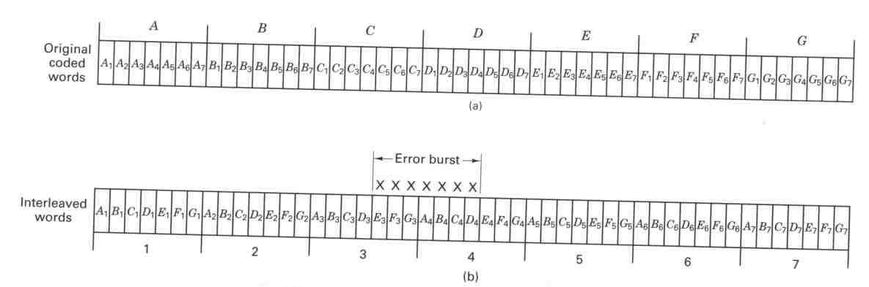

Figure 3.1 Interleaving example [18].

The interleaver shuffles the code symbols over a span of several block lengths (for block codes) or several constraint lengths (for convolutional codes). The span required is determined by the burst duration. The details of the bit redistribution pattern must be known to the receiver in order for the symbol stream to be deinterleaved before being decoded. Figure 3.1 illustrates a simple interleaving example. In Figure 3.1(a) we see seven uninterleaved code words, A through G. Each codeword is comprised of seven code symbols. Let us assume that the code has a single-error-correcting capability within each seven-symbol sequence. If the memory span of the channel is one codeword in duration, such a seven-symbol-time noise burst could destroy the information contained in one or two codewords. However, suppose that, after having encoded the data, the code symbols were then interleaved or shuffled, as shown in Figure 3.1(b). That is, each code symbol of each codeword is separated from its preinterleaved neighbours by a span of seven symbol times. The interleaved stream is then used to modulate a waveform that is transmitted over the channel. A contiguous channel noise burst occupying seven symbol times is seen in Figure 3.1(b), to affect one code symbol from each of the original seven codewords. Upon reception, the stream is first deinterleaved so that it resembles the original coded sequence in Figure 3.1(a). Then the stream is decoded. Since each codeword possesses a single-error-correcting capability, the burst noise has no degrading effect on the final sequence.
Interleaving techniques have proven useful for all the block and convolutional codes. Two types of interleavers are commonly used: block interleavers and convolutional interleavers [18].

3.3 Types of Interleaving

Interleaving plays an important role in many digital communication systems for manifold reasons. In the context of mobile radio communications, fading channels often lead to bursty errors, that is, several successive symbols may be corrupted by deep fades. This has a crucial impact on the decoding performance, for example, of convolutional codes because of its sensitivity to bursty errors. In order to overcome this difficulty, interleaving is applied. At the transmitter, an interleaver simply permutes the data stream b [_] in a specified manner (see Figure 3.2), so that the symbols are transmitted in a different order. Consequently, a deinterleaver has to be employed at the receiver, in order to reorder the symbols back into the original succession [14].

Figure 3.2 Structure of block interleaver of length L_{π} = 12

In Figure 3.2, the structure of block interleaver is shown with the length of (L_{π} = 12). In another hand, interleavers can be classified into two broad types: periodic interleavers, and pseudorandom interleavers. In periodic interleavers, symbols of the transmitted sequence are scrambled as a periodic function of time.

    - Random Interleaver

A pseudorandom interleaver permutes each block of symbols pseudorandomly. Pseudorandom interleavers may be applied to channel symbols, but their main application is as critical elements in turbo encoders and encoders of serially concatenated codes that use iterative decoding.
The desired permutation may be stored in a read-only memory (ROM) as a sequence of addresses or permutation indices. Each block of symbols is written sequentially into a RAM matrix and then interleaved by reading them in the order dictated by the contents of the ROM. If the interleaver is large, it is often preferable to generate the permutation indices by an algorithm rather than storing them in a ROM. If the interleaver size is L_{π} =MN=2^{v}-1, then a linear feedback shift register with v stages that produces a maximal-length sequence can be used (M_rows number, N_colomns number). The binary outputs of the shift-register stages constitute the state of the register. The state specifies the index from 1 to N that defines a specific interleaved symbol. The shift register generates all N states and indices periodically. An S-random interleaver is a pseudorandom interleaver that constrains the minimum interleaving distance. The application of block interleaving in concatenated coding schemes generally leads to a weak performance. Due to the regular structure of the interleaver it may ensue that the temporal distance between pairs of symbols does not change by interleaving, resulting in poor distance properties of the entire code. Therefore, random or pseudorandom interleavers are often applied in this context.
Pseudorandom interleavers can be generated by calculating row and column indices with modulo arithmetic. For concatenated coding schemes, interleavers are optimized with respect to the constituent codes.

3.3.2 Periodic Interleaver

In periodic interleavers, symbols of the transmitted sequence are scrambled as a periodic function of time. The two main classes of periodic interleaving are: block interleaving and convolutional interleaving.

3.3.2.1 Block Interleaver
A block interleaver accepts the coded symbols in blocks from the encoder, permutes the symbols, and then feeds the rearranged symbols to the modulator. The usual permutation of the block is accomplished by filling the columns of an M-row-by N-column (M x N) array with the encoded sequence. After the array is completely filled, the symbols are then fed to the modulator one row at a time and transmitted over the channel. At the receiver, the deinterleaver performs the inverse operation; it accepts the symbols from the demodulator, deinterleaves them, and feeds them to the decoder. Symbols are entered into the deinterleaver array by rows, and removed by columns. Figure 3.3(a) illustrates an example of an interleaver with M = 4 rows and N = 6 columns. The entries in the array illustrate the order in which the 24 code symbols are placed into the interleaver. The output sequence to the transmitter consists of code symbols removed from the array by rows, as shown in the figure. The most important characteristics of such a block interleaver are as follows:
- Any burst of less than N contiguous channel symbol errors results in isolated errors at the deinterleaver output that are separated from each other by at least M symbols.
- Any bN burst of errors, where b > 1, results in output bursts from the deinterleaver of no more than ┌ b ┐ symbol errors. Each output burst is separated from the other bursts by no less than M - └ b ┘ symbols. The notation ┌ x ┐ means the smallest integer no less than x, and └ x ┘ means the largest integer no greater than x.
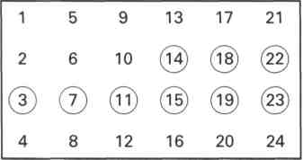
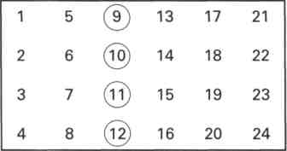
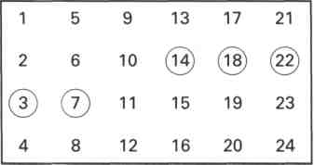
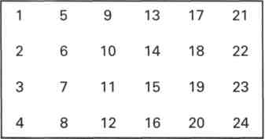

(a) MxN block interleaver. (b) Five-symbol error burst.

(c) Nine-symbol error burst. (d) Periodic single error sequence
spaced N=6 symbols apart.
Figure 3.3 Block interleaver example [18].

- A periodic sequence of single errors spaced N symbols apart results in a single burst of errors of length M at the deinterleaver output.
- The interleaver/deinterleaver end-to-end delay is approximately 2MN symbol times. To be precise, only M(N - 1) + 1 memory cells need to be filled before transmission can begin (as soon as the first symbol of the last column of the M x N array is filled). A corresponding number needs to be filled at the receiver before decoding begins. Thus the minimum end-to-end delay is (2MN - 2M + 2) symbol times, not including any channel propagation delay.
- The memory requirement is MN symbols for each location (interleaver and (deinterleaver). However, since the MxN array needs to be (mostly) filled before it can be read out, a memory of 2MN symbols is generally implemented at each location to allow the emptying of one MxN array while the other is being filled, and vice versa.
Typically, for use with a single-error-correcting code the interleaver parameters are selected such that the number of columns N over bounds the expected burst length. the choice of the number of rows M is dependent on the coding scheme used.
For block codes, M should be larger than the code block length, while for convolutional codes, M should be larger than the constraint length. Thus a burst of length N can cause at most a single error in any block codeword; similarly, with convolutional codes, there will be at most a single error in any decoding constraint length. For t-error-correcting codes, the choice of N need only over bound the expected burst length divided by t [18].

3.3.2.1.1 General Block Interleaver

A block interleaver performs identical permutations on successive blocks of symbols, Thus, the successive input symbols are stored in a random-access memory (RAM) as a matrix of rows and columns.
The input sequence is written into the interleaver in successive rows, but successive columns are read to produce the interleaved sequence. Thus, if the input sequence is numbered 1, 2, …, n, n+1, …, mn, the interleaved sequence is 1, n+1, 2n+1, …, 2, n+2, …, mn. For continuous interleaving, two RAMs are needed. Symbols are written into one RAM matrix while previous symbols are read from the other. In the deinterleaver, symbols are stored by column in one matrix, while previous symbols are read by rows from another. Consequently, a delay of 2mn must be accommodated and synchronization is required at the deinterleaver. When channel symbols are interleaved, the parameter n equals or exceeds the block codeword length or a few constraint lengths of a convolutional code.
Consequently, if a burst of m or fewer consecutive symbol errors occurs and there are no other errors, then each block codeword or constraint length, after deinterleaving, has at most one error, which can be eliminated by the error correcting code. Similarly, a block code that can correct t errors is capable of correcting a single burst of errors spanning as many as mt symbols. Since fading can cause correlated errors, it is necessary that mTs exceed the channel coherence time. Interleaving effectiveness can be thwarted by slow fading that cannot be accommodated without large buffers that cause an unacceptable delay.

3.3.2.1.2 Helical Scan Interleaver

Other types of interleavers that are closely related to the block interleaver include the convolutional interleaver and the helical interleaver. A helical interleaver reads symbols from its matrix diagonally instead of by column in such a way that consecutive interleaved symbols are never read from the same row or column. Both helical and convolutional interleavers and their corresponding deinterleavers confer advantages in certain applications, but do not possess the inherent simplicity and compatibility with block structures that block interleavers have.

3.3.2.2 Convolutional Interleaving
Convolutional interleavers have been proposed by Ramsey [19] and Forney [20]. The structure proposed by Forney appears in Figure 3.4. The code symbols are se-quentially shifted into the bank of N registers; each successive register provides J symbols more storage than did the preceding one. The zeroth register provides no storage (the symbol is transmitted immediately). With each new code symbol the commutator switches to a new register, and the new code symbol is shifted in while the oldest code symbol in that register is shifted out to the modulator/transmitter. After the (N - l)th register, the commutator returns to the zeroth register and starts again. The deinterleaver performs the inverse operation, and the input and output commutators for both interleaving and deinterleaving must be synchronized.
Figure 3.5 illustrates an example of a simple convolutional four-register interleaver being loaded by a sequence of code symbols. The synchronized deinterleaver is shown simultaneously feeding the deinterleaved symbols to the decoder. Figure 3.5(a) shows symbols 1 to 4 being loaded.
From
Encoder
To
Encoder

Figure 3.4 Shift registration implementation of a convolutional interleaver/deinterleaver [18].
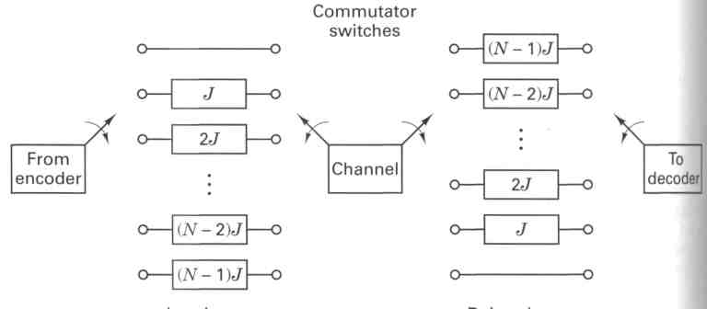
To
encoder
To
encoder
Figure 3.5(b) shows the first four symbols shifted within the registers and the entry of symbols 5 to 8 to the interleaver input. Figure 3.5(c) shows symbols 9 to 12 entering the interleaver. The deinterleaver is now filled with message symbols, but nothing useful is being fed to the decoder yet.
Finally, Figure 3.5(d) shows symbols 13 to 16 entering the interleaver, and at the output of the deinterleaver, symbols 1 to 4 are being passed to the decoder. The process continues in this way until the entire codeword sequence, in its original preinterleaved form, is presented to the decoder. The performance of a convolutional interleaver is very similar to that of a block interleaver.
The important advantage of convolutional over block interleaving is that with convolutional interleaving the end-to-end delay is M(N - 1) symbols, where: M = NJ, and the memory required is M(N - 1)/2 at both ends of the channel. Therefore, there is a reduction of one-half in delay and memory over the block interleaving requirements [21].
Interleaver Deinterleaver
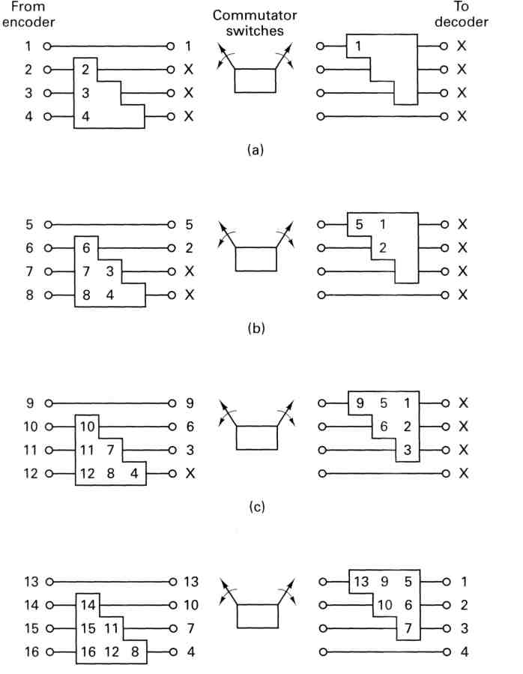

Figure 3.5 Convolutional interleaver/deinterleaver examples [18].
3.4 Time Diversity and Interleaving

Time diversity is a scheme whereby the same information signal is sent at different time slots through the channel. When two time slots that contain the same information signal are separated by a time greater than the coherence time(Δt)_{c} of the channel, the signals from these two separate transmissions fade independently. As a result, the signals from different time slots are uncorrelated with each other. This is an attempt to break up the cluster of errors. Interleaving is an effective method to combat the burst error.
Instead of sending the same information signals several times over the channel. the information bit sequence is interleaved at the transmitter so that after deinterleaving at the receiver, the transmission errors have minimum correlation. This can be achieved by separating the transmission of two successive information bits in the time domain by no less than (Δt)_{c} Interleaving does not require additional bandwidth.
It is easy to incorporate interleaving into a communication system so that a random error correcting code can be used. Time diversity and interleaving can be combined in the CDMA cellular systems without adding a major modification to the existing systems. The resultant scheme is chip interleaving. Chip interleaving improves the bit error rate performance when it is compared to the conventional block symbol interleaving [22].

3.5 Interleaving Delay

A tight restriction to the total size of interleavers may occur for delay sensitive applications such as full duplex speech transmission. Here, delays of only around 10 ms are tolerable. Since the interleaver has to first be completely written before it can be read out, its size Lπ directly determines the delay _t = Lπ · Ts where, Lπ was standed for the interleaver size and Ts for interleaving delay.

3.5.1 Effect of Delays on Recovery of Convolutionally Interleaved Data

If a convolutional interleaver is used and followed by a corresponding convolutional deinterleaver, then a nonzero delay means that the recovered data (that is, the output from the deinterleaver) is not the same as the original data (that is, the input to the interleaver). If the two data sets are compared directly, then the delay must be taken into account by using appropriate truncating or padding operations. Here are some typical ways to compensate for a delay of D in an interleaver/deinterleaver pair:
• Interleave a version of the original data that is padded with D extra symbols at the end. Before comparing the original data with the recovered data, omit the first D symbols of the recovered data. In this approach, all the original symbols appear in the recovered data.
• Before comparing the original data with the recovered data, omit the last D symbols of the original data and the first D symbols of the recovered data. In this approach, some of the original symbols are left in the deinterleaver’s shift registers and do not appear in the recovered data [8].

3.5.2 Combining Interleaving Delays and Other Delays

If convolutional interleavers is used in a script that incurs an additional delay, d, between the interleaver output and the deinterleaver input (for example, a delay from a filter), then the restored sequence lags behind the original sequence by the sum of d and the amount of delay that can be taken from tables for Interleaver/Deinterleaver Pairs.
In this case, d must be an integer multiple of the number of shift registers, or else the convolutional deinterleaver cannot recover the original symbols properly. If d is not naturally an integer multiple of the number of shift registers, then you can adjust the delay manually by padding the vector that forms the input to the deinterleaver [8].

3.6 Summary

In this chapter, interleaving process has been illustrated. Two main types of interleavers, namely periodic and pseudo-random interleavers, have been described. As part of periodic interleaving, the details of block, helical scan and convolutional interleaving methods are given.
In the next chapter, jamming methods will be described and details of the most common jamming methods, narrowband jamming, broadband jamming and pulsed broadband jamming, are explained.

